**CLONING**



**1.HTTPS**

**STEP 1**: Copy link from code in repository

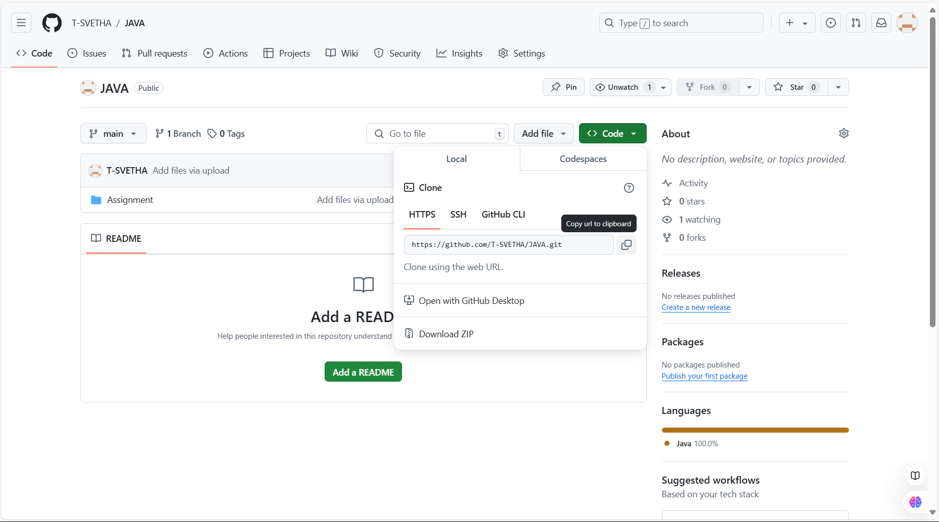



**STEP 2:** Select add and click import repository

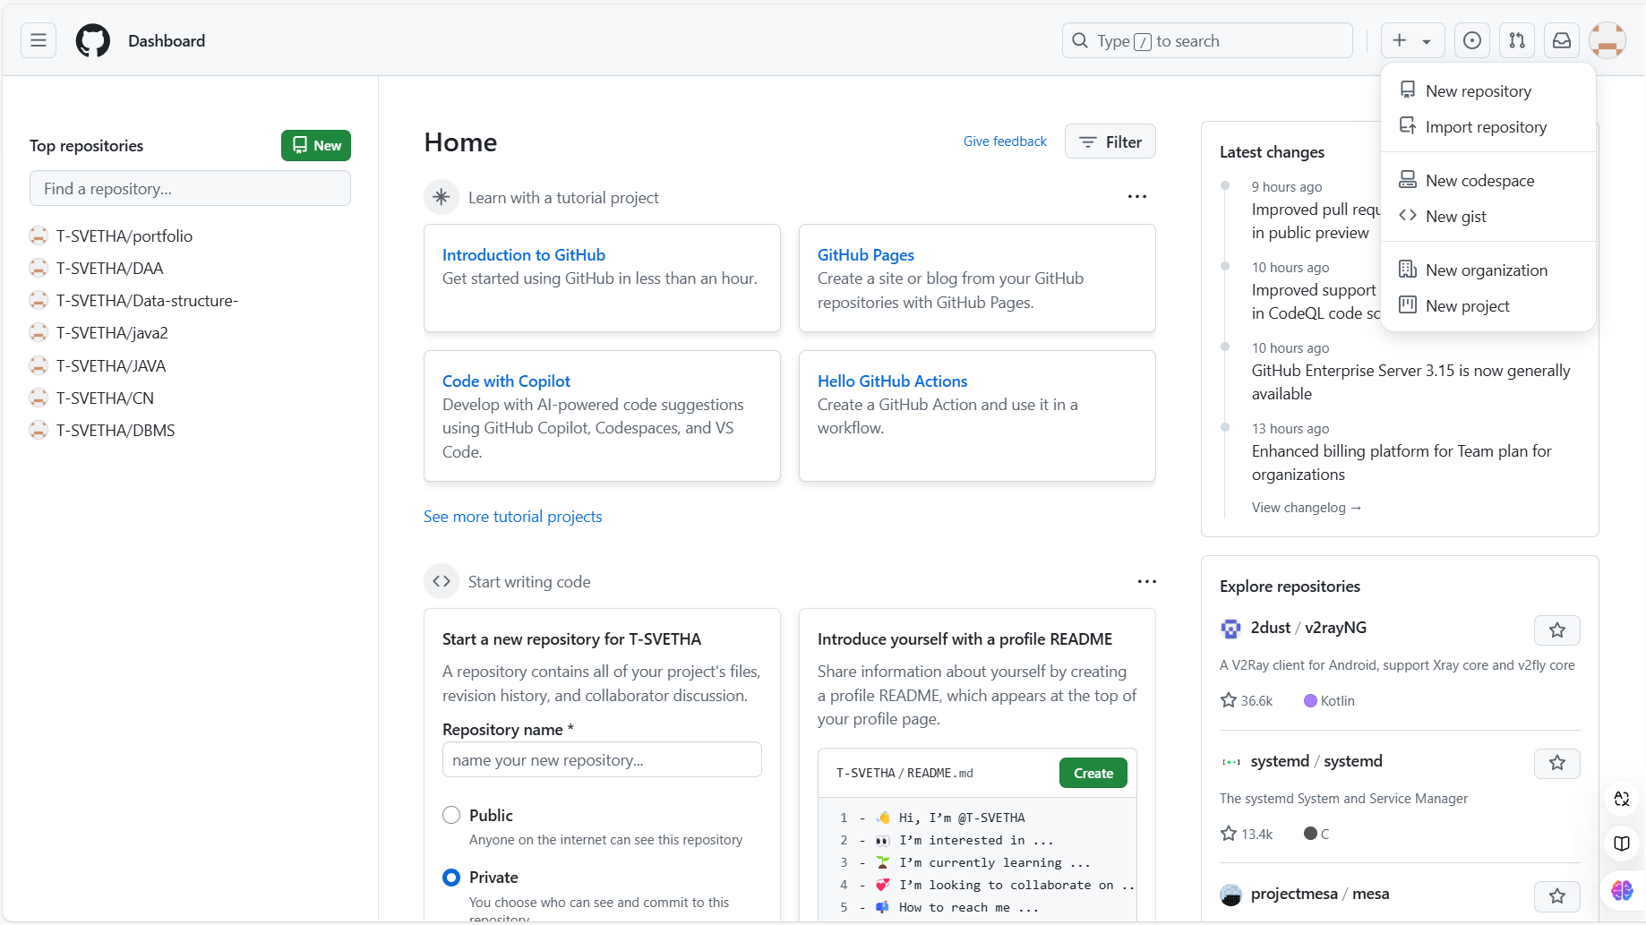



**STEP 3**: Paste the url in the given box and a repository name. click begin import

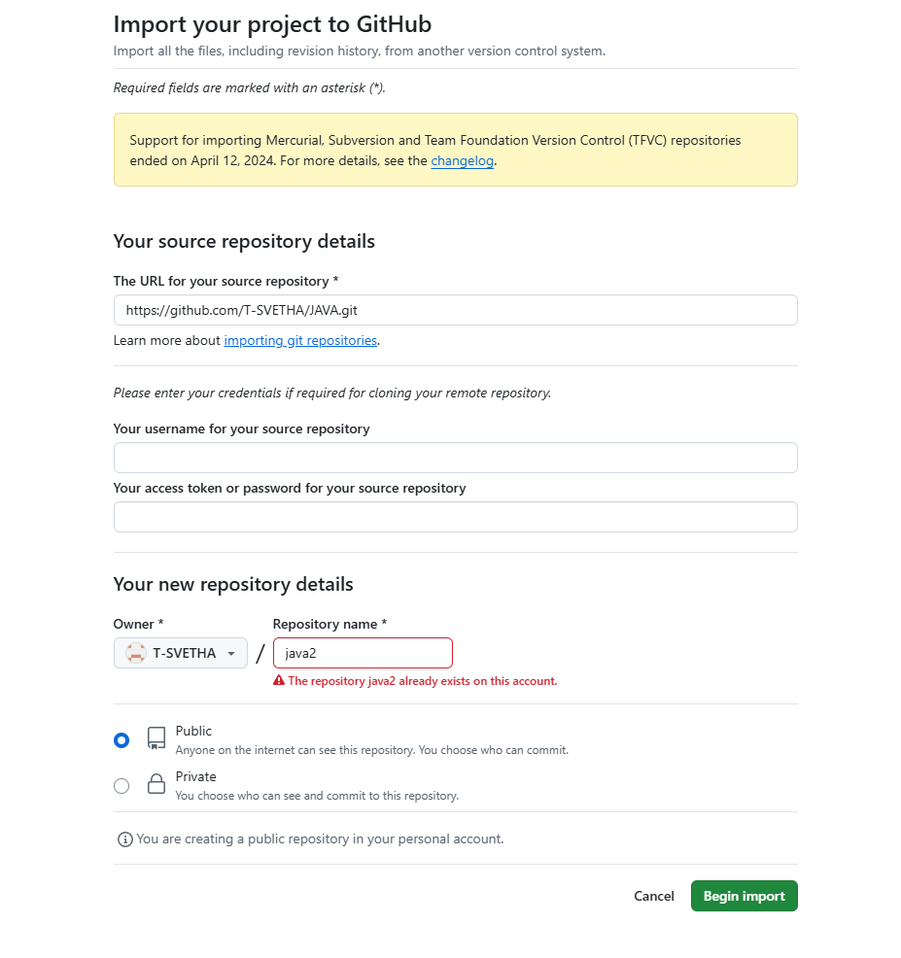



**STEP 4:** Now your repository is cloned and this can be also done by cloning from one account to another

